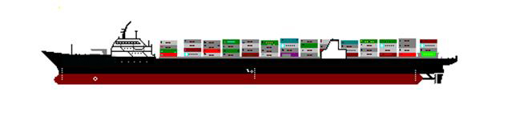
Captain
J. Mark Tuck

o

Chief Mate
Sorin Rosca

Guest of honor
Charles Coleman III

Second Mate
Christian Ranosa
(626) 636-1927

AB watch 4 x 8
Nicholas Howard

AB watch 12 x 4
Julius Dagoldol

Boatswain
Sanje Gupta

Third Mate
Marc Logan

o

Chief Engineer
Luis Navarrete

AB Day 4 x 8
Zaid Said

AB Day 12 x 4
Jaquaz Jenkins

AB watch 8 x 12
Matthew Epstein

o

First Engineer
Austin Jensen

o

‘Gas’ Second Engineer day
Edward ‘Ed’ Albrecht

Second Engineer 4 x 8
Josef Eggert

Third Engineer 12 x 4
Maurice Welsh

Third Engineer 8 x 12
Johanna Ortiz

o

Electrician
Kirk chambers

QMED 12 x 4
Allen Newgen

QMED 4 x 8
Dwight Hunt

QMED 8 x 12
Loren Arriola

o

Deck Engine Utility
Kevin Marty Berrera

Steward
James Harper

cook
Rogelio Nunez

Steward Assistant
Robert “Skip” Lee

o

Deck Cadet
Keep Dreaming

Engine Cadet
Well Not Likely

Supervisory Port Engineer
Michael Popovich

S.I.U. Apprentice - D
Frankly I. Doubtit

S.I.U. Apprentice - C
Will C. Maybe

S.I.U. Apprentice - B
Patrick O’Malley

S.I.U. Apprentice - A
Sean Mullen

o

